中華電力有限公司

CLP Power Hong Kong Limited

技術服務部

TECHNICAL SERVICES DEPARTMENT

深水埗福華街 215號 3樓

3/F., Sham Shui Po Centre,

215 Fuk Wa Street,

Shamshuipo, Kowloon,

HONG KONG.

電話 Tel (852) 2678 6180

傳真 Fax (852) 2678 6000

網址 Website www.clpgroup.com

|  |  |
| --- | --- |
| 致 To | ${consultantTitle} ${consultantOtherNames} ${consultantSurname} |
|  | ${consultantCompanyName} |
| 傳真號碼 Fax/電郵 Email | ${consultantEmail} |
| 發送人 From | Mr Edmond Chan |
|  | Principal Manager - Systems Engineering |
| 傳真號碼 Fax | 2678 6000 |
| 電話號碼 Tel | 2678 7893 |
| 發送人參考編號 Our Ref | 248-17/Fax/F/${faxRefNo}/${faxDate} |
| 收信人參考編號 Your Ref |  |
| 日期 Date | ${issueDate} |
| 總頁數 Total pages | 9 (including this page) |

如傳送過程中出現問題，請即致電 (852) 2678 6180。

If you do not receive all pages of this fax or have any problem with the transmission, please telephone (852) 2678 6180.

**Dear ${consultantTitle} ${consultantSurname},**

|  |
| --- |
| **Invitation of Power Quality (PQ) Planning Ahead Meeting for the Project, “${projectTitle}”** |

With reference to your application of the new supply for your development project, you and your Project Owner are cordially invited to join the captioned PQ planning ahead meeting at the PQ Laboratory meeting room, 4/F, CLP Shamshuipo Office, 215 Fuk Wa St., Sham Shui Po, Kowloon or through MS Teams.

Many PQ issues can be avoided by planning in advance before the design and purchase of new electrical equipment. It is much more cost-effective to incorporate PQ requirements in the plan and design stage to prevent the potential PQ problems than fixing the problems after the equipment is put into service. Hence, some valuable planning ahead PQ Tips for planning a new project development or purchasing new equipment would be introduced during the PQ planning ahead meeting.

Please fill in the attached “Reply Slip for Customer Designs on Voltage Dip Ride-thru and Harmonics Emission” to let us more understand what type of equipment would be installed in this project so that we can advise the appropriate PQ Tips.

You may be aware that modern electrical or electronic equipment may be sensitive to power quality (PQ) issues such as voltage dips and harmonics. As your energy partner, CLP Power is committed to providing reliable and stable power supply. However, like many power systems in other cities, voltage dips are unavoidable because of various external factors. They include interference to overhead lines by adverse weather (e.g. typhoon, lightning strikes) or foreign objects (e.g. overgrown vegetation, wild lives); damage to underground cables caused by road works of third parties, etc. In some cases, voltage dips can also be caused by faults in interconnected power networks beyond CLP Power’s boundary. Also, harmonic current is usually caused by the customers’ non-linear loadings such as power electronic equipment.

We are committed to assist our customers to resolve PQ issues and hence, we would like to share relevant experience with our customers. Please kindly refer to the Attachment 1 – Problem Solving & Planning Ahead table which summarizes the symptoms, possible causes and recommended mitigation measures for details.

We strongly encourage you and your Project Owner to accept this free professional PQ planning ahead meeting service invitation and fill in the attached Reply Slip before project implementation for a thorough assessment of critical equipment to combat PQ issues and alleviate the impact. Should you have any enquires with the above or arrange a PQ Planning Ahead meeting with us, please feel free to contact our Mr K.Y. Poon (tel: 2678 6047 or email: benpoon@clp.com.hk) or Mr K.W. Chan (tel: 2678 7518 or email: kw.chan@clp.com.hk).

Yours sincerely,

CLP Power Hong Kong Limited

Edmond Chan

Principal Manager - Systems Engineering

ec:nc:zy

**Attachment 1**

**Problem-Solving & Planning Ahead table**

|  |  |  |
| --- | --- | --- |
| Appliance | Symptom | Recommendation |
| Air- Conditioners (Residential) | * Original design did not cater for load growth and use   of high-demand appliances, like air- conditioner.   * Customer’s main building ACB tripped after voltage dip as a result of over-current protection activated due to excessive restart current surge. | The tripping of the main ACB is attributable to uneven load distribution, high load demand under hot weather conditions, and sudden load fluctuations during a voltage dip incident.  For high-rise buildings:   * Internal supply upgrade or load diversion is proposed in order to reserve more capacity for sudden load demands and current fluctuations. * Check if there is spare transformer bay and spare main incoming circuit breaker on customer LV board, please contact power company for   considering addition of transformer or other supply upgrade if the reserved capacity is insufficient for load fluctuation. |
|  |  | * Replacement of conventional window- type or split-type A/C by inverter-type. |
|  |  | * Precise estimation of load growth and close monitoring of load demand would be necessary. |
| *Planning Ahead Tips*   * *Reserved capacity for load fluctuation.* * *A/C or large machine-starting current under normal and voltage dip conditions.* * *A/C with instant compressor cut-off on voltage dip and automatic time-delay reset.* * *Window-type or split-type A/C with inverter for smaller starting current.* | | |

|  |  |  |
| --- | --- | --- |
| Appliance | Symptom | Recommendation |
| LV Changeover Scheme | * LV changeover scheme malfunctioned after voltage dip and resulted in interruption to the essential supply. | * To employ DC supply for the changeover and other control schemes because AC-driven relays malfunctioned during voltage dip incidents. This is similar to most fire and security systems that employ DC with battery back-up as control supply to enhance scheme reliability. To be more reliable, use battery-less UPS as control supply during voltage dips. * To employ coil hold-in device to reduce the chance of relay-chattering under voltage dip conditions. * To employ true off-delay relay to coordinate with the under-voltage relay in order to allow a short delay before issuing trip signal to the respective breaker under voltage dip conditions, or start command to standby generator. * It would be desirable to adjust the voltage setting of the scheme in order to allow sufficient margin to ignore transient disturbances which may be produced by the starting of heavy machinery or sudden load changes   at the load side. The operating time setting should be long enough to ride-through most voltage dips in order to achieve higher reliability. |
| *Planning Ahead Tips*   * *Reliability of the scheme under voltage dips.* * *Use of DC scheme and equipping with battery and charger.* * *True off-delay timer.* * *Over-/ under-voltage and time-delay setting of changeover scheme.* | | |

|  |  |  |
| --- | --- | --- |
| Appliance | Symptom | Recommendation |
| Lifts | * Lift tripped and with passenger ‘shut-in-   lift’ during voltage-dip. | * If no hidden mechanical defects, the lift should be able to automatic restart and perform the ‘Homing’ function, which is an essential feature of the fireman’s lift. Inclusion of checking of   automatic restart or power loss homing function in maintenance procedures should be considered.   * If the homing time was too long during restarting, an emergency floor opening in the tunnel zone could be modified as a landing floor for passenger evacuation. Alternatively, high-speed floor locating should be considered. Low-speed floor locating during restart is always misinterpreted by passengers as shut-in-lift. * If the lift tripped on stalled-motor timer when the lift was repositioning itself at low speed, a sensor should be added in order to feedback running status to reset the timer. Alternatively, high-speed floor locating software should be considered. * Mechanical defects and damaged voltage arrestors should be cleared and replaced during compulsory routine maintenance. * Effective intercom to duty guard post is desirable (instead of relaying to unmanned machine room). * Lift-status display lantern should be considered for comforting passengers when the lift has tripped or is restarting at low speed. * Dynamic reactive compensator should be added to reduce voltage dip caused by starting current surge. * Voltage dip immunity components should be considered to enhance the ride-through capability of the control circuits and/ or motor drive. * Adopt lift modernization to include post- voltage-dip operation (PVDO) feature (please refer to the latest edition of ‘COP on the Design and Construction of Lifts and Escalators’) and Automatic Rescue Device (ARD) should be considered. * Advanced type motor drive equipped with kinetic buffering and/ or regenerative feature should be considered. |
| *Planning Ahead Tips*   * *Voltage dip ride-through capability of the lift.* * *Effectiveness of automatic restart or homing feature of lift under different conditions after a voltage dip.* | | |

|  |  |  |
| --- | --- | --- |
| Appliance | Symptom | Recommendation |
| Escalator | * Escalator tripped during voltage- dip. | * It was recommended to add an UPS to secure the power to the control contactors and PLC. * In addition, the PM relay was replaced with a new relay equipped with a short time delay allowing the escalator to ride through the voltage dip for 0.2 second. * To modify the settings of VSD in order to enhance ride-through capability. * Some VSD provide a voltage dip ride- through feature should be considered,   e.g. kinetic buffering, which requires enabling by users.   * DC buffering unit can be added to supply energy to VSD during voltage dip. * For adding ride-through feature, a two- stage under-voltage (UV) relay should be used to comply with requirements in “Code of Practice (COP) on the Design   and Construction of Lifts and Escalators”.   * For public safety, an escalator with “soft- stop” function allowing it to slow down gradually during failures should also be considered. |
| *Planning Ahead Tips*   * *Voltage dip ride-through capability of the escalator.* * *VSD voltage dip ride-through setting, voltage dip/ power loss automatic restart setting.* | | |
| Variable Speed Drive | * Control contactor dropped off. * Variable speed drive tripped under voltage dip. | * It is recommended to by-pass the control contactor and also modify the VSD to take up the ON/OFF control function. * The VSD voltage dip/ power loss automatic restart function should be activated in this case. To be more reliable, ride-through device should be used. * DC buffering unit can be added to supply energy to VSD during voltage dip. * These requirements have been incorporated in the purchasing specifications for new machines. |
| *Planning Ahead Tips*   * *Control contactor drop-off.* * *VSD voltage dip ride-through setting, voltage dip/ power loss automatic restart setting.* * *Specifications for new machines.* | | |

|  |  |  |
| --- | --- | --- |
| Appliance | Symptom | Recommendation |
| Uninterruptible Power Supply (UPS) and Automatic Transfer Switch (ATS) | * RCD tripped when UPS ran at battery mode (discharging) and UPS out-of-sync alarm came up. * UPS discharged or ATS (automatic transfer switch) operated too frequently. * Sensitive equipment tripped even when UPS was provided. | * It is recommended to add a harmonic- suppression filter or equivalent device. Harmonic-immune RCD should be considered alternatively. * UPS/ ATS voltage sensitivity set too high and caused UPS to switch to battery mode or ATS to operate on minor voltage variations and shorten equipment life. * Switched-type UPS was used and it responded too slowly under marginal voltage fluctuation condition. It is recommended to use true on-line UPS. |
| *Planning Ahead Tips*   * *UPS voltage rating, sensitivity level and mode of operation, i.e. switched- type or true on-line type.* | | |
| Capacitor Bank | * Capacitor bank blown out frequently. * Neutral conductor high temperature. * Computerised and Telecommunications equipment failure. | * Harmonics of the building too high. * Add harmonic-suppression filter. * Baseline measurement and periodic review of harmonic level would be desirable. |
| *Planning Ahead Tips*   * *Estimate harmonic level of all related circuits.* * *Harmonics of future equipment added/ installed by tenants.* * *Application of active harmonic filter.* | | |

|  |  |  |
| --- | --- | --- |
| Appliance | Symptom | Recommendation |
| Residual Current Device (RCD) | * RCD tripped occasionally after voltage dip. | * High harmonic content could be a major cause of RCD tripping. The addition of a harmonic-suppression filter is suggested. * The cumulative trace capacitance of electronic device/ computer loads could introduce transient leakage current under voltage dip conditions and thus trigger the operation of the RCD. * It is recommended to consult an electrical contractor on adding a new and selecting a correct type of RCD and checking the insulation and   current leakage on individual devices.   * Harmonic-immune RCDs are available on the market which can provide leakage protection for circuits with high harmonics. |
| *Planning Ahead Tips*   * *Estimated harmonic level of all related circuits.* * *Harmonics of future equipment added/ installed by tenants.* * *Application of active harmonic filter.* | | |

|  |  |  |
| --- | --- | --- |
| Appliance | Symptom | Recommendation |
| Electrical Vehicle Charging Cystem | * RCD tripped occasionally after voltage dip. | * High harmonic content could be a major cause of RCD tripping. The addition of a harmonic-suppression filter is suggested. * The cumulative trace capacitance of electronic device/ computer loads could introduce transient leakage current under voltage dip conditions and thus trigger the operation of the RCD. * It is recommended to consult an electrical contractor on adding a new and selecting a correct type of RCD and checking the insulation and   current leakage on individual devices.   * Harmonic-immune RCDs are available on the market which can provide leakage protection for circuits with high harmonics. |
| *Planning Ahead Tips*   * *Estimated harmonic level of all related circuits.* * *Harmonics of future equipment added/ installed by tenants.* * *Application of active harmonic filter.* * *EV charger’s ancillary control system and the load management system for smart EV charging station shall comply with the international practices of voltage dip ride through capability, such as Semiconductor Equipment and Materials International (SEMI) F47 , IEC 61000-4-11:2004, IEC 61000-4-34:2005 or Samsung Power Vaccine Standard. Should these chargers and the load management system for these chargers not comply with the mentioned international standards, addition of ride through equipment such as battery-less UPS for protecting the control supply shall be provided* | | |

**Recommendation**

* Obtain advice and suggestions from manufacturers and CLP Power.
* Make reference to international practices about “voltage dip ride-through capability”. Among the many sources are: the Information Technology Industry Council (ITIC) recommended capability curve or the Semiconductor Equipment and Materials International (SEMI) standards or the IEC 61000-4-34, -4-11 on Voltage Dip Immunity Standard or Samsung Power Vaccine Standard.
* Incorporate relevant ride-through / restart / backup requirement in new equipment specification.

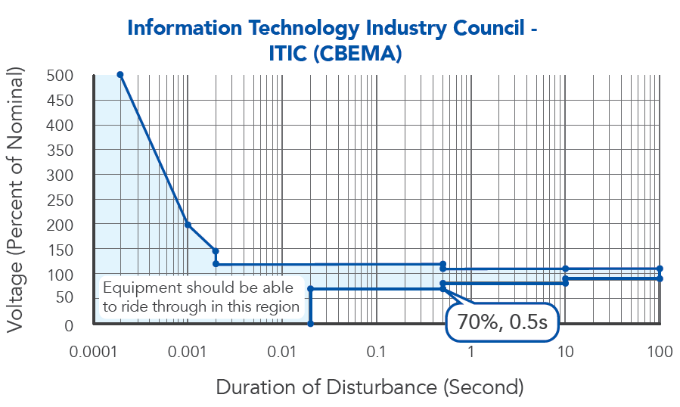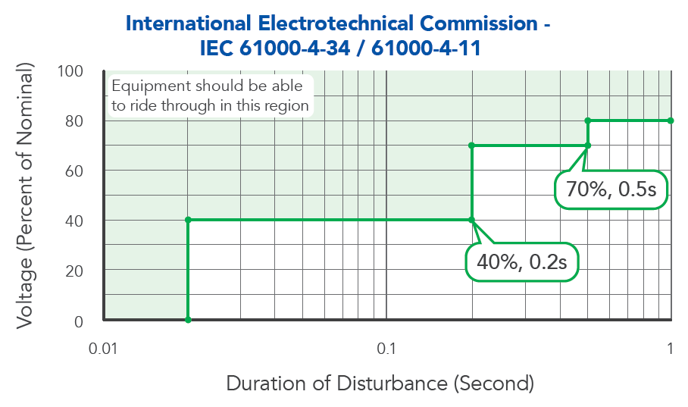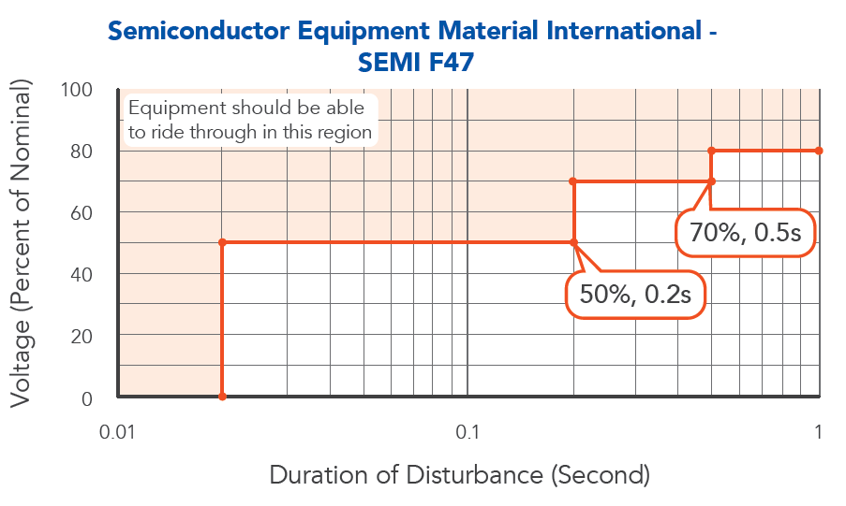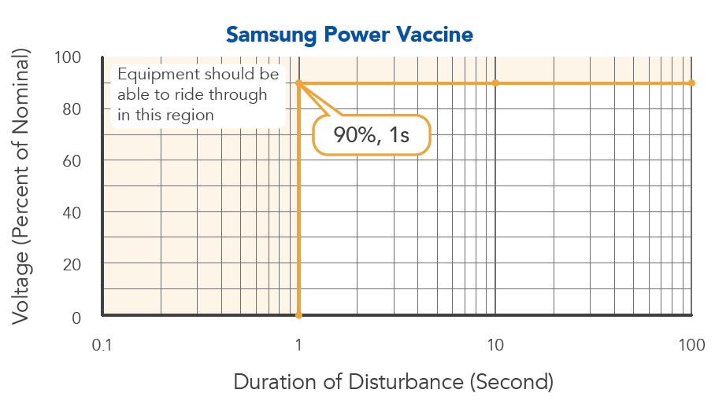

– End –